**CIS 375 - Fall 2019 Term Project - BRAINS**



Use Case Summary Document

**Version No. 1**

**Project Document Revision History**

|  |  |  |  |
| --- | --- | --- | --- |
| **VersionNumber** | **Date** | **Revision Author** | **Description of Revision** |
| 0.0.2 | 10/21/2019 | Zakriya Ahmad | Edit the Use Case Summary |
|  |  |  |  |

|  |
| --- |
| **Table of Contents** |

1. Introduction 4

2. Project/Application Actors 4

3. Use Case List 4

4. Use Case Diagram(s) 5

5. Use Case Summary 6

6. Use Case Summary Review and Signoff 7

# Introduction

This document captures BUSINESS requirements at a high level by identifying ALL the use cases in a project/application.

This project will create a unified system for companies to track and ensure all of their departments are following required guidelines and regulations. Right now, companies are relying on trust of each department that they are following requirements, and keeping it in an organized fashion. This program will be a software that is easy to use, with effective methods to keep all of the data organized, with proof that each department is following the regulations, so there is no doubt that they are being followed.

When companies do not follow regulations, if they get caught, it can be timely and expensive, as they have to fix the problem before they can work on anything else, as well as be fined. Once this program is in place, it will save the headaches of going through each regulation manually, and remove the risk of getting a fine due to not following the rules.

# Project/Application Actors

An actor is someone or something (e.g. application system) outside the system or business that interacts with the application. List the actors involved in ANY use case. Actors should be a person, system, or time.

|  |  |
| --- | --- |
| Actor Name | Description |
| Audit company | Can review questions and files uploaded by each department if they are authorized by each the oversight team. also providing feedback if necessary. |
| Database | Holds an array of data: questions, answers, usernames, and passwords. |
| Departments | Employees of each departments answer questions and upload files as need necessary. |
| Oversight team | Manages the system and Questions and files submitted by Departments with the ability to modify/add both. |

# Use Case List

List ALL use cases identified for the project/application.

1. Answer Submission and Completion
2. Login and Account Creation
3. Question Maintenance
4. Report Generation
5. Report Management
6. Users and Departments Management

# Use Case Diagram(s)

Show diagram(s) that - ALL actors and ALL use cases identified in sections 2 and 3 must be represented somewhere in the diagram(s). IF multiple use case diagrams are created because of groupings of business functionality assigned a number and name to each diagram for ease of reference.

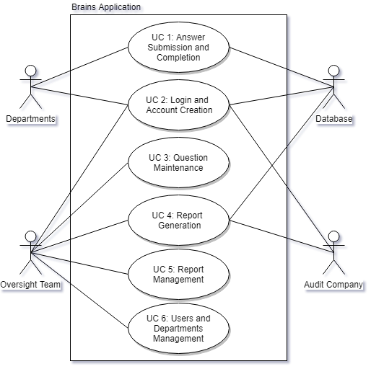

# Use Case Summary

For each use case include: Introduction of use case (one paragraph, will also be “introduction” to individual use case specification document), use case diagram number and name reference (if exists), list of main actors and list of secondary actors (these MUST match the lists in the individual use case specification document).

1. Answers

This is the use case of answering and storing questions. Databases store the answers, receiving it from the Departments. The Departments answer the STEINERS, which gets sent to the Database. This is Use Case 1, with the departments and databases as actors.

1. Login creation and account creation

This is to check if a user has validation to login and answer the questions, as well as creation of user accounts. Oversight companies create the accounts, while databases store accounts, with departments having accounts. The audit system logins in, to see the report that are submitted to them. This is Use Case 2, with the Database, Departments, Oversight Team and Audit Team as actors.

1. Question Maintenance

This is the adding, removing or modification of questions done by the Oversight team.. These get sent to departments for answering. This is Use Case 3, with the Oversight Team as the actor.

1. Report Generation

This is the generation of a report, for viewing. The Oversight Team and Audit Company get a report to review, while the Database stores the report. This is Use Case 4, with Oversight Team, Database, and Audit Company as actors.

1. Report management

This is the deadline of a report, as well as the updating of report question. This is done by the Oversight team. This is Use Case 5, with the Oversight Team as the actors.

1. Users and Department Management

This is the creation of users/experiments done by the Oversight team. This is to create new departments, as well creating new users for that department. This is Use Case 6, with the Oversight Team as the actors.

# Use Case Summary Review and Signoff

|  |  |  |  |
| --- | --- | --- | --- |
| Review and Signoff of the Use Case Summary | | | |
| Name | Project Team Role | Signature | Date |
| Ahmed, Zakariya | Senior Tech Lead/SPMP manager | Z.A. | 10/16/2019 |
| Alhaidar, Muaz | Developer | M.A. | 10/16/2019 |
| Longworth, Kevin | Developer | K.L. | 10/16/2019 |
| Labut, Cameron | Developer | C.L. | 10/16/2019 |
| Majzoub, Mostafa El | Developer | M.M. | 10/16/2019 |